System Design

DFD:

A data flow diagram is a way to depict a flow of a process or device data. Also, the DFD contains knowledge about each entity's outputs and inputs, and the process itself. There is no power flow in a data-flow model, there are no decision rules and no loops.

DFD of a Company:

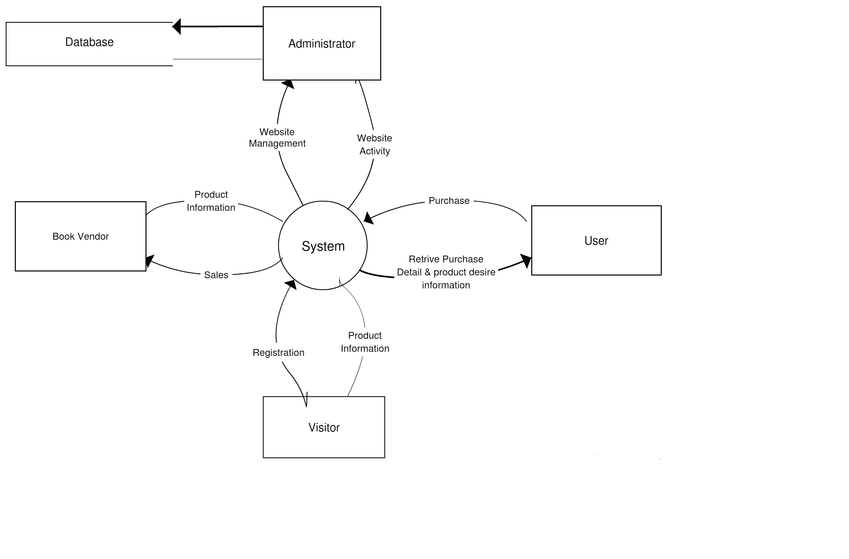

Basic DFD of a example E-Commerce Website:

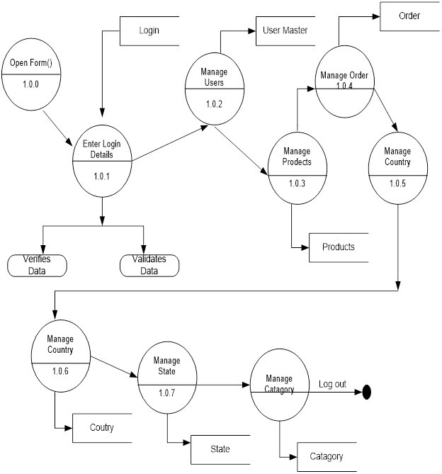

ER-Diagram:

An entity – relationship model defines interrelated matters of concern in a specific information domain. A simple ER model is composed of types of entities and defines the relationships between entities that may exist.

ER-Diagram of a company website database:

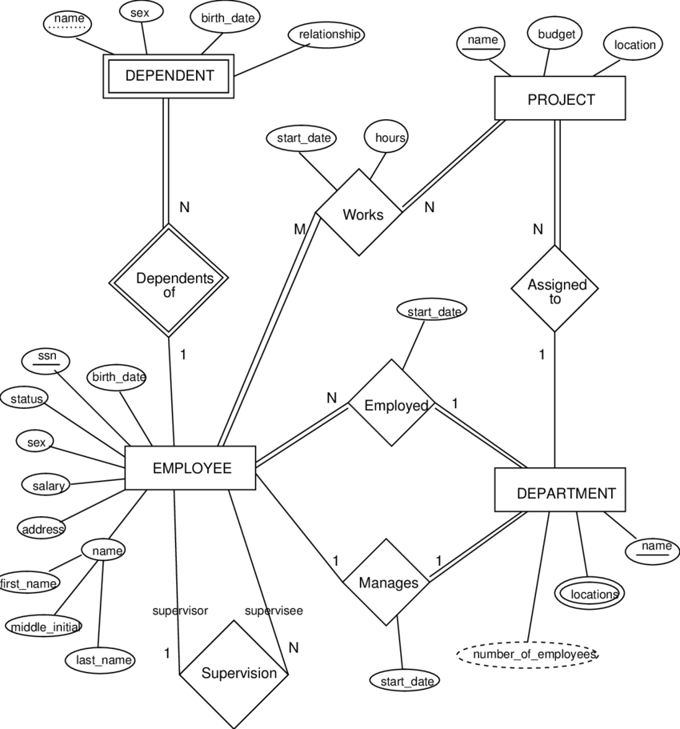

Flow Chart:

A flowchart is a kind of diagram describing a procedure or workflow. You can also describe a flowchart as a diagrammatic representation of an algorithm, a step-by-step approach to resolving a problem. The flowchart displays the steps as different types of boxes, and their order by connecting the boxes to arrows.

Basic example company website flowchart:

